Set up Manual PostgreSQL

1. Download - <https://www.enterprisedb.com/downloads/postgres-postgresql-downloads>



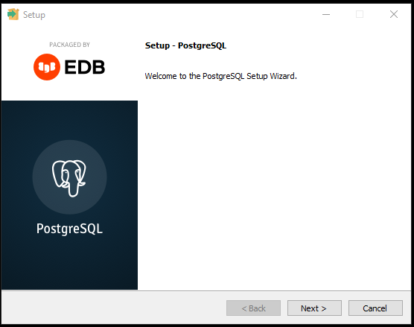

1. Setup password please REMEMBER!!! (in this case we use “password”)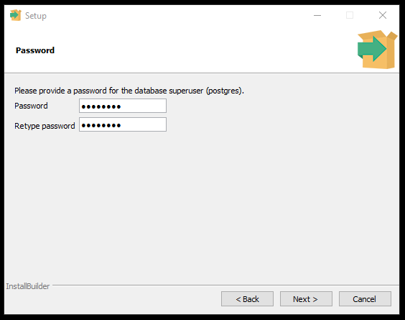
2. Set Port 5432

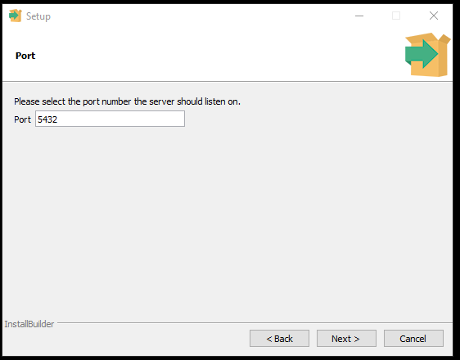

1. Installing

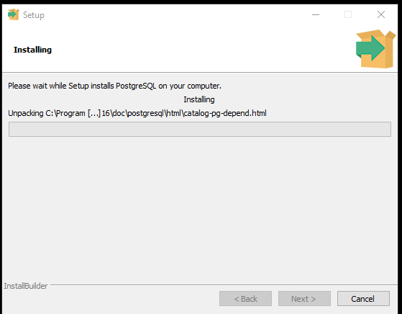

1. Complete – Click finish

